Window_a

Reconstruction | 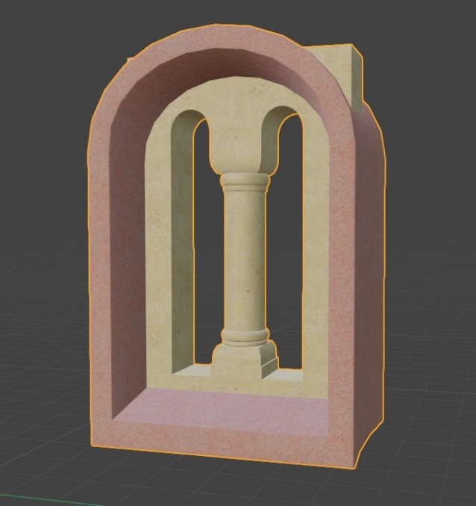
Used sources | Report_text_page11 | 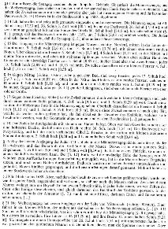
 | photo_museum_01 | 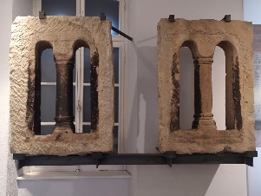
Uncertainty | The windows on the western façade are still existing (now in museum) and are therefore level 4. The windows of the eastern wall were reconstructed based on the windows from the museum. | Windows West wall: Level 4  Windows East wall:  Level 3
Argumentation | On the basis of the museum photo, a simple cube was used in combination with two cylinders as Booleans to create the bifocal shape of the window. The dimensions were taken from the report text page 11 by Georg Litzel. The column of the window was added as an extra cylinder mesh, while the upper and lower parts of the columns were built from the leftovers of the Boolean in the cube.

Window_b

Reconstruction | 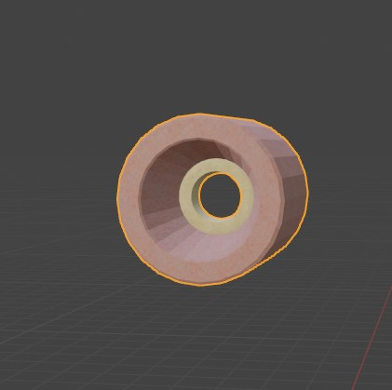
Used sources | Report_text_page11
 | report_drawing_05 | 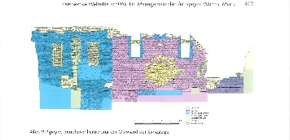
 | photo_location_10 | 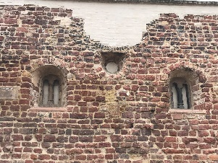
Uncertainty | As there are still windows visible in each wall, the level of uncertainty is 4 = still existing | Level 4
Argumentation | The report drawing was taken as the basis for the reconstruction and dimension of the window, while the photo was used to see how deep the windows were set into the wall. The dimensions were compared to the report text page 11 by Georg Litzel. The windows were reconstructed with a cylinder, that was solidified and a cylinder as a Boolean.

Window_c

Reconstruction | 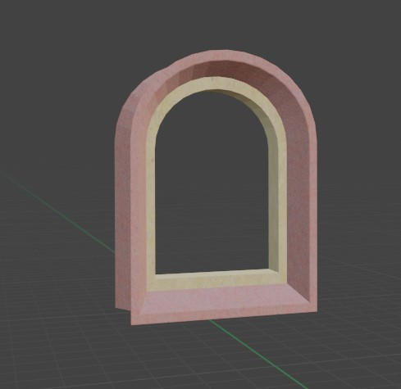
Used sources | Report_text_page11
Uncertainty | The windows don’t exist any more and there are no visible markings in the walls to reconstruct the placement or dimensions of the windows. | Level 2
Argumentation | The dimensions, structure and placement were taken from the report text page 11 by Georg Litzel. The windows were reconstructed with a cylinder, which was cut in half and solidified, this was then copied and used as a Boolean.

Wall_a

Reconstruction | 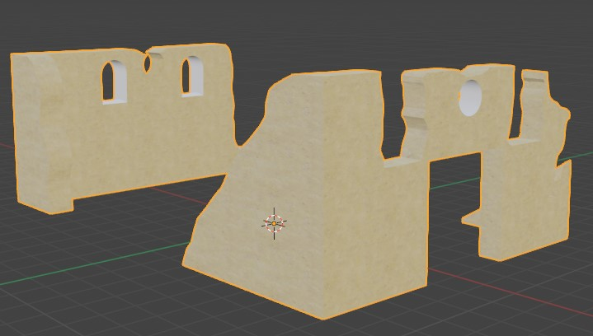
Used sources | report_drawing_05
 | report_drawing_03 | 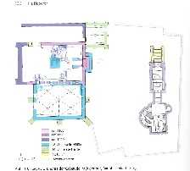
 | photo_location_02 | 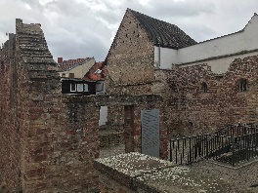
 | photo_location_03 | 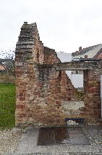
 | photo_location_09 | 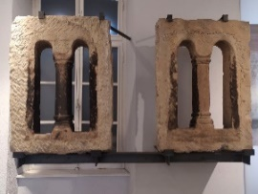
Uncertainty | These wall are still existing and were examined and dated to specific time periods | Level 4
Argumentation | The dimensions of the wall were taken from report_drawing_03 and 05, with the difference to the reconstructed walls taken from the photographs.

Wall_b

Reconstruction | 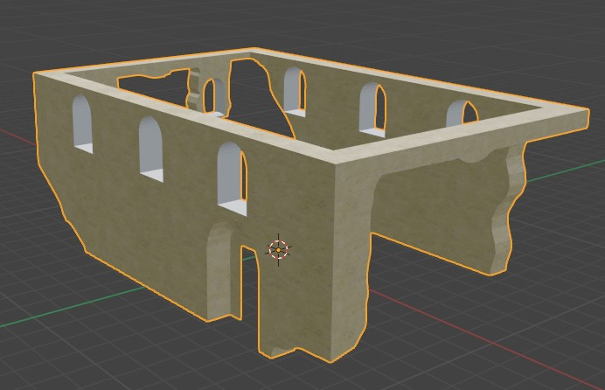
Used sources | report_drawing_05
 | report_drawing_03
Uncertainty | These walls were reconstructed based on the missing areas between the ruins of the walls, that can be still seen today. | Level 3
Argumentation | The dimensions of the wall were taken from report_drawing_03 and 05, with the difference to the reconstructed walls taken from the photographs. The walls were first created from a cube, with a different cube as a Boolean and then cut with the Knife tool to separate the still existing wall (a) and the reconstructed wall (b).

Foundation

Reconstruction | 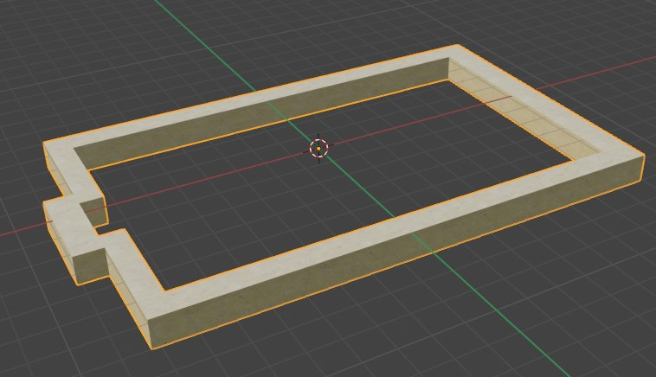
Used sources | report_drawing_03
Uncertainty | The foundation can still be found today and was examined in the archaeological excavation. | Level 4
Argumentation | The dimensions were taken from the report_drawing_03 and the height was defined at 1 Meter.

Floor

Reconstruction | 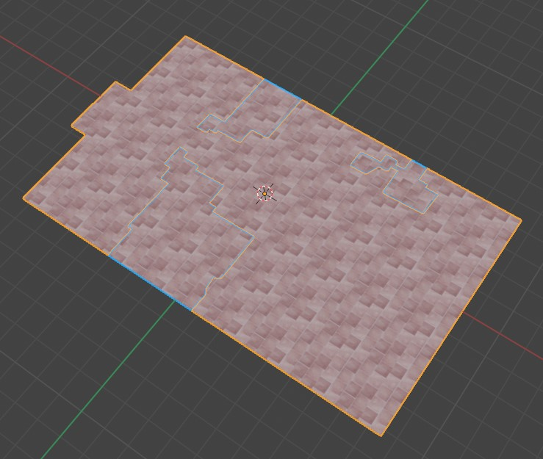
Used sources | report_drawing_03
Uncertainty | In the report drawing some of the floor parts are marked as still existing (level 4), the rest was deducted (level 3) | Level 4  Level 3
Argumentation | The floor was reconstructed with the report drawing as a basis. First a cube was modelled to fit the dimensions of the synagogue, with the Knife tool the still existing floor part were cut out and then separated.

Doorway

Reconstruction | 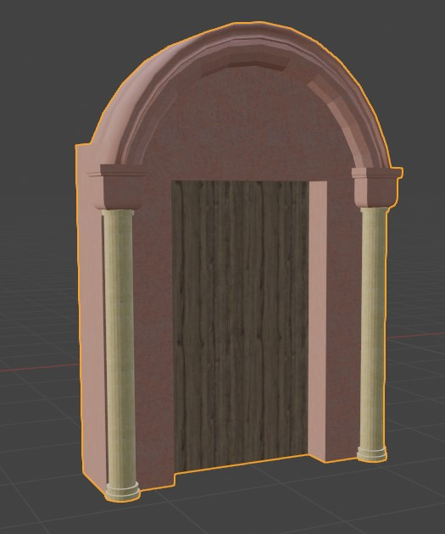
Used sources | analogy_02_01 | 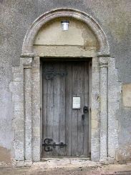
 | report_drawing_03
Uncertainty | There is not much left of the doorway, so the doorway of analogy_02 was used | Level 2
Argumentation | The basic structure of analogy_02 was used to recreate and reconstruct the doorway of the synagogue. The width was taken from the report_drawing_03. The doorway was modelled by combining cubes and cylinders and using Booleans to create the opening for the door.

Plinth

Reconstruction | 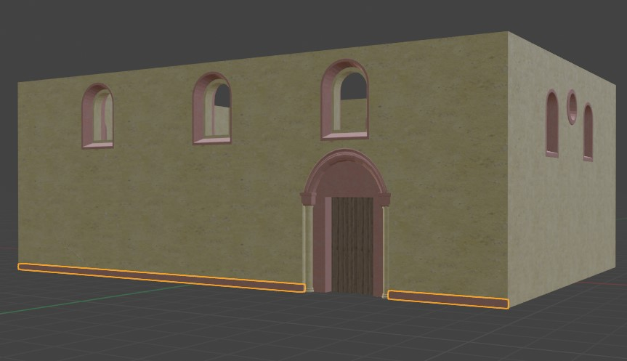
Used sources | report_text_Page27 | 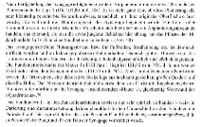
 | report_text_Page95_Abb28 | 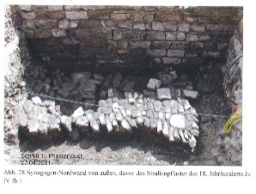
Uncertainty | There are no definitive images of the plinth, but in the archaeological report it is mentioned, that the plinth was found in the excavation | Level 4
Argumentation | Based on the archaeological report the plinth was added with a simple cube, fitting with the dimensions of the northern façade.

Aron HaKodesh

Reconstruction | 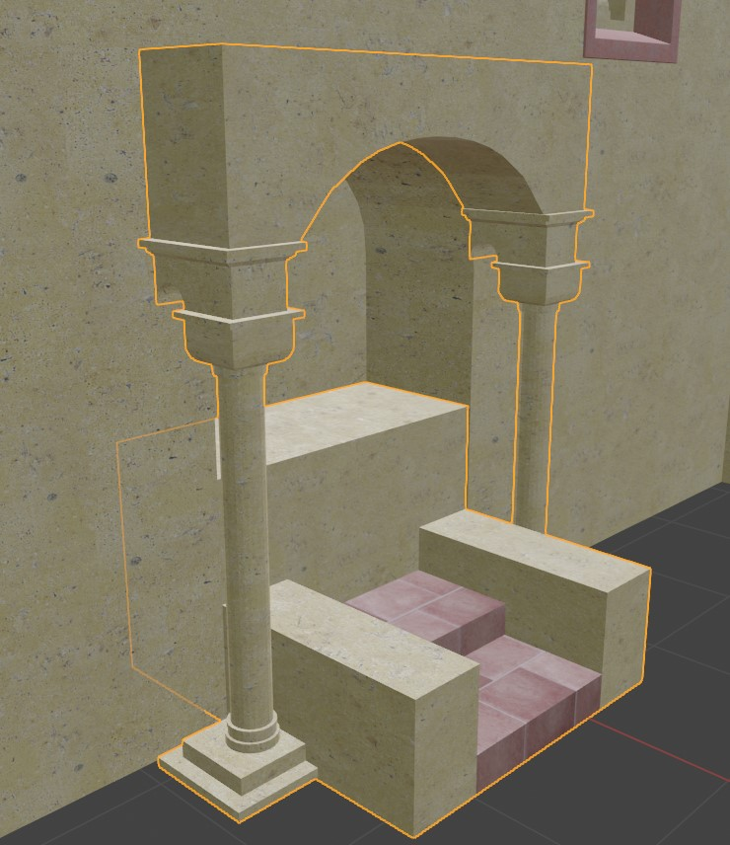
Used sources | report_drawing_05
 | article_01_Page183_Abb17_18 | 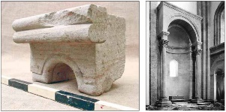
Uncertainty | There is not much left of the Aron Hakodesh, which led to the use of analogies, mainly the text and images from article_01 | Level 2
Argumentation | The reconstruction was mainly based on article_01 and modelled to fit with the rest of the Aron Hakodesh, which was visible in the eastern wall. The reconstruction was created with cubes, cylinders and Booleans, which were modelled to fit the overall look found in article_01.

Cornice

Reconstruction | 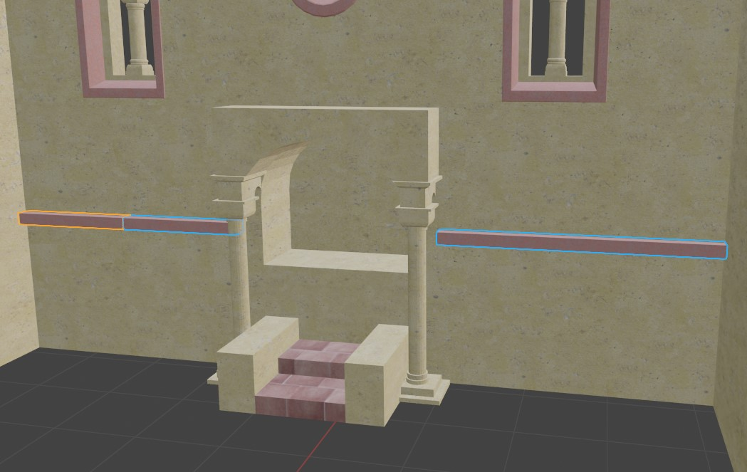
Used sources | article_01_Page182_Abb14 | 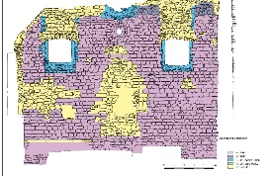
 | photo_location_11 | 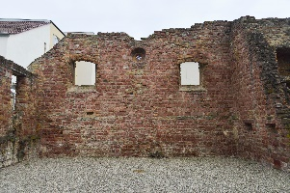
Uncertainty | There are still parts of the cornice visible (level 4) the rest of the cornice was reconstructed (level 3) | Level 4  Level 3
Argumentation | The drawing of the inner wall was mainly used to reconstruct the cornice and model the missing parts. A cube was used to build the cornice, which was then separated to the still existing and the reconstructed parts.

Beams_c

Reconstruction | 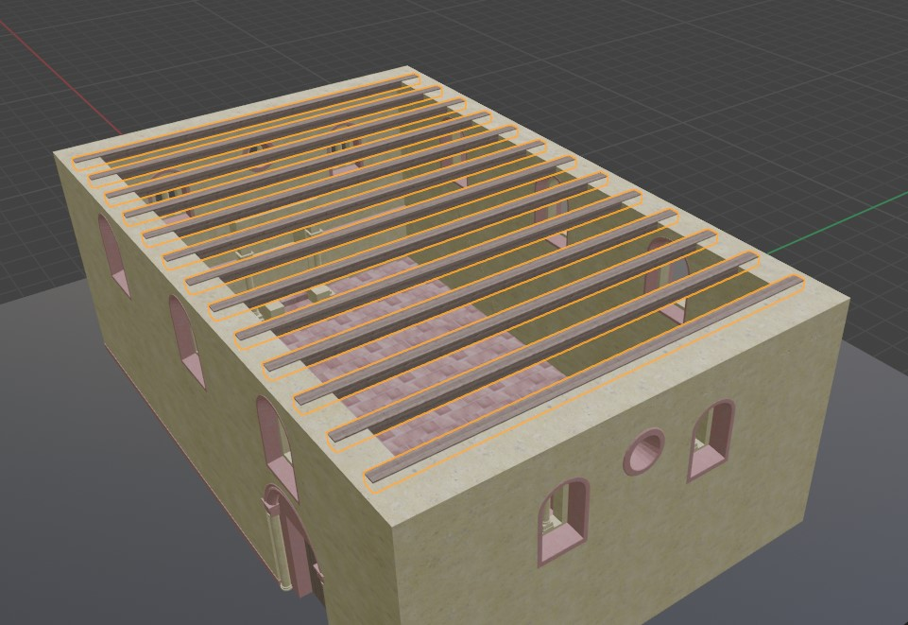
Used sources | http://www.urbs-mediaevalis.de/pages/studienportal/bauteiltypologie/bauteile-w/walmdach.php | 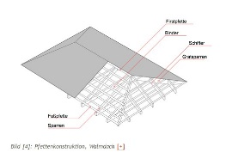
 | http://www.urbs-mediaevalis.de/pages/studienportal/bauteiltypologie/bauteile-w/walmdach.php | 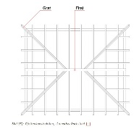
Uncertainty | The beams and roof of the synagogue don’t exist anymore, there are no fitting analogy to use for the reconstruction | Level 1
Argumentation | Without any analogies or similar structures, the beams were modelled after the architectural basics of the type of roof, that was defined for the synagogue. The beams were reconstructed from cubes, which were multiplied with the Array modifier.

Ceiling

Reconstruction | 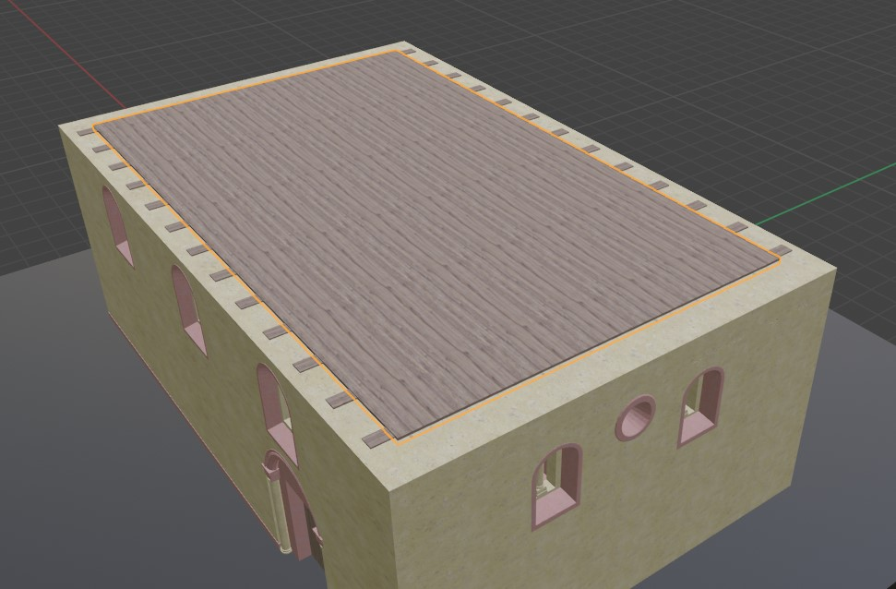
Used sources | There are no sources
Uncertainty | The beams and roof of the synagogue don’t exist anymore, and there is no source for a ceiling between the beams for the roof | Level 1
Argumentation | A ceiling was added, which is also the floor of the attic. It was modelled from a cube and set on top of the beams c.

Beams_b

Reconstruction | 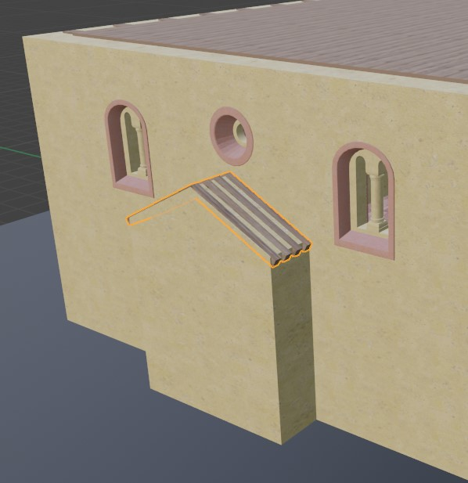
Used sources | http://www.urbs-mediaevalis.de/pages/studienportal/bauteiltypologie/bauteile-s/satteldach.php?searchresult=1&sstring=satteldach#wb_460 | 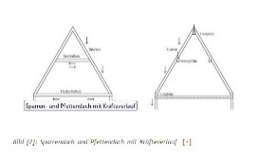
Uncertainty | The beams and roof of the synagogue don’t exist anymore, there are no fitting analogy to use for the reconstruction | Level 1
Argumentation | Without any analogies or similar structures, the beams were modelled after the architectural basics of the type of roof, that was defined for the synagogue. The beams were reconstructed from cubes, which were multiplied with the Array modifier.

Beams_a

Reconstruction | 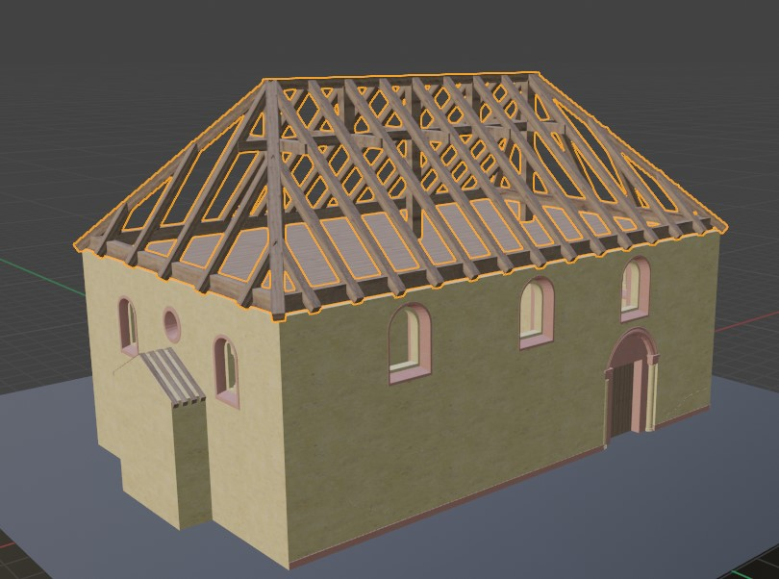
Used sources | http://www.urbs-mediaevalis.de/pages/studienportal/bauteiltypologie/bauteile-w/walmdach.php
 | http://www.urbs-mediaevalis.de/pages/studienportal/bauteiltypologie/bauteile-w/walmdach.php
Uncertainty | The beams and roof of the synagogue don’t exist anymore, there are no fitting analogy to use for the reconstruction | Level 1
Argumentation | Without any analogies or similar structures, the beams were modelled after the architectural basics of the type of roof, that was defined for the synagogue. The beams were reconstructed from cubes, which were multiplied with the Array modifier.

Roof_b

Reconstruction | 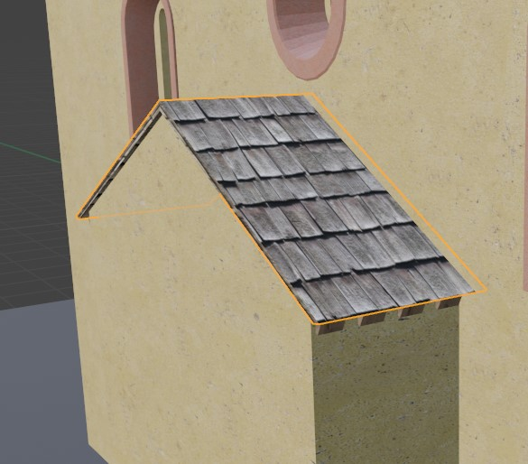
Used sources | http://www.urbs-mediaevalis.de/pages/studienportal/bauteiltypologie/bauteile-s/satteldach.php?searchresult=1&sstring=satteldach#wb_460
Uncertainty | The beams and roof of the synagogue don’t exist anymore, there are no fitting analogy to use for the reconstruction | Level 1
Argumentation | Without any analogies or similar structures, the roof was modelled to fit the structure of the beams.

Roof_a

Reconstruction | 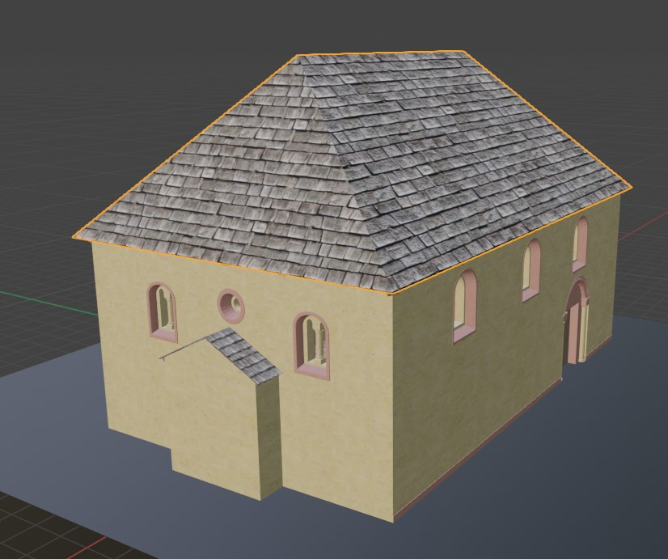
Used sources | http://www.urbs-mediaevalis.de/pages/studienportal/bauteiltypologie/bauteile-w/walmdach.php
 | http://www.urbs-mediaevalis.de/pages/studienportal/bauteiltypologie/bauteile-w/walmdach.php
Uncertainty | The beams and roof of the synagogue don’t exist anymore, there are no fitting analogy to use for the reconstruction | Level 1
Argumentation | Without any analogies or similar structures, the roof was modelled to fit the structure of the beams.

Hierarchy and Uncertainty in Blender:
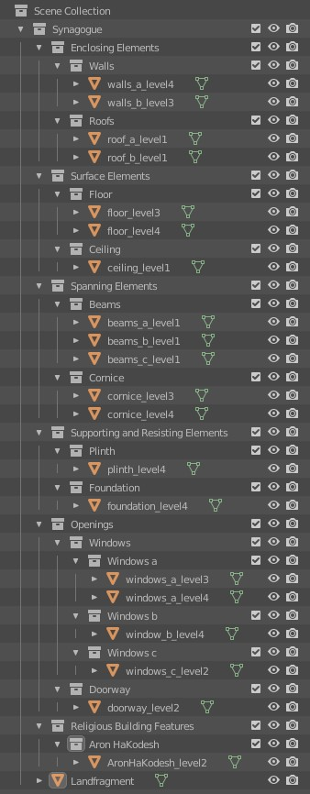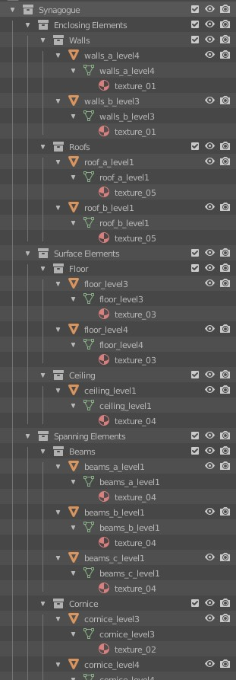
Fig. 1 Fig. 2
In the collections () Fig. 1, that were defined through the hierarchy in the handout, each element was placed, with the correct name as the object property () as well as the correct object data property () Fig. 2.

